LAB 5 ANP-C7781

Solve following questions:

1. Write a Java program that reads a string from the user and uses StringTokenizer to split the string into individual words. Print each word on a new line.

Program :-

package Day07;

import java.util.StringTokenizer;

import java.util.Scanner;

public class StrTokenizerProgram {

// Main method to start the program

public static void main(String[] args) {

// Create a new Scanner object to read from the console

Scanner scanner = new Scanner(System.***in***);

// Print a text to the console asking the user to enter a string

System.***out***.println("Enter a string: ");

// Read the user's input and store it in the 'input' variable

String input = scanner.nextLine();

// Create a new StringTokenizer object with the input string

StringTokenizer tokenizer = new StringTokenizer(input);

// Loop through each token in the tokenizer

while (tokenizer.hasMoreTokens()) {

// Get the next token and store it in the 'word' variable

String word = tokenizer.nextToken();

// Print the word on a new line

System.***out***.println(word);

}

// Close the Scanner object to free up system resources

scanner.close();

}

}

Output :-

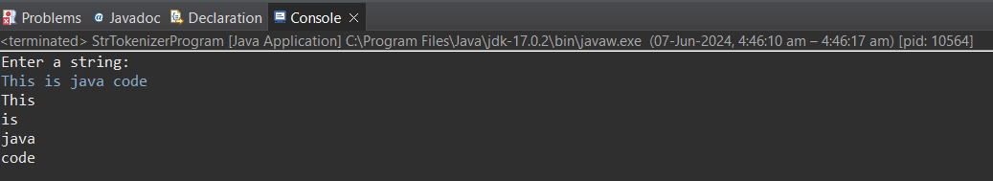

1. Write a Java program that reads a string from the user and uses StringTokenizer to count the number of words in the string.

Program :-

package Day07;

import java.util.StringTokenizer;

import java.util.Scanner;

public class StrTokenizerCount {

// Main method to start the program

public static void main(String[] args) {

// Create a new Scanner object to read from the console

Scanner scanner = new Scanner(System.***in***);

// Print a prompt to the console asking the user to enter a string

System.***out***.println("Enter a string: ");

// Read the user's input and store it in the 'input' variable

String input = scanner.nextLine();

// Create a new StringTokenizer object with the input string

StringTokenizer tokenizer = new StringTokenizer(input);

// Initialize a variable to keep track of the word count

int wordCount = 0;

// Count the number of tokens (words) in the string

while (tokenizer.hasMoreTokens()) {

// Increment the word count for each token

wordCount++;

// Get the next token to prepare for the next iteration

tokenizer.nextToken();

}

// Print the number of words in the string

System.***out***.println("Number of words: " + wordCount);

// Close the Scanner object to free up system resources

scanner.close();

}

}

Output :-

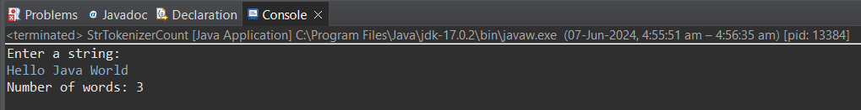

1. Write a Java program to create a LinkedList of strings, add elements at specific positions (beginning, middle, end), and print the list.

Program :-

package Day07;

import java.util.LinkedList;

public class StrLinkedList {

public static void main(String[] args) {

// Create a new LinkedList to store strings

LinkedList<String> linkedList = new LinkedList<>();

// Add elements to the beginning of the list

linkedList.addFirst("Element 0");

linkedList.addFirst("Element 1");

// Add elements to the middle of the list

linkedList.add(1, "Element 2");

// Add elements to the end of the list

linkedList.addLast("Element 3");

linkedList.addLast("Element 4");

// Print the current state of the LinkedList

System.***out***.println("LinkedList: " + linkedList);

}

}

Output :-

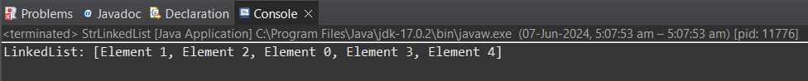

1. Write a Java program to sort a given array list.

Program :-

package Day07;

import java.util.ArrayList;

import java.util.Collections;

public class SortArrayList {

public static void main(String[] args) {

// Create an ArrayList

ArrayList<Integer> list = new ArrayList<>();

list.add(4);

list.add(1);

list.add(7);

list.add(2);

list.add(8);

// Print the original list

System.***out***.println("Original List: " + list);

// Sort the list using the Collections.sort() method

Collections.*sort*(list);

// Print the sorted list

System.***out***.println("Sorted List: " + list);

}

}

Output :-

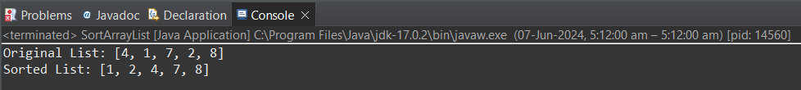

1. Write a Java program to replace the second element of an ArrayList with the specified element.

Program :-

package Day07;

import java.util.ArrayList;

public class ArrListReplaceElement {

public static void main(String[] args) {

// Create an ArrayList to store strings

ArrayList<String> list = new ArrayList<>();

list.add("Apple");

list.add("Banana");

list.add("Cherry");

list.add("Date");

// Print the original list

System.***out***.println("Original List: " + list);

// Replace the second element of the list with a new element

list.set(1, "Mango");

// Print the updated list

System.***out***.println("Updated List: " + list);

}

}

Output :-

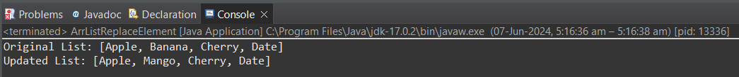

1. Write a Java program to iterate a linked list in reverse order.

Program :-

package Day07;

import java.util.LinkedList;

public class ReverseLinkedList {

public static void main(String[] args) {

// Create a LinkedList to store strings

LinkedList<String> list = new LinkedList<>();

list.add("Apple");

list.add("Banana");

list.add("Cherry");

list.add("Date");

// Print the original list

System.***out***.println("Original List: " + list);

// Iterate the list in reverse order

// Start from the last element of the list

for (int i = list.size() - 1; i >= 0; i--) {

// Print each element in reverse order

System.***out***.println(list.get(i));

}

}

}

Output :-

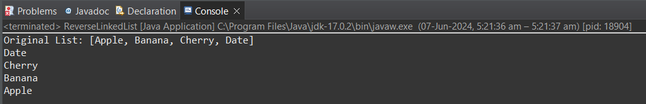

1. Write a Java program to retrieve, but not remove, the last element of a linked list.

Program :-

package Day07;

import java.util.LinkedList;

public class RetrieveLastElement {

public static void main(String[] args) {

// Create a LinkedList to store strings

LinkedList<String> list = new LinkedList<>();

list.add("Apple");

list.add("Banana");

list.add("Cherry");

list.add("Date");

// Print the original list

System.***out***.println("Original List: " + list);

// Retrieve the last element of the list

// The getLast() method returns the last element of the list

String lastElement = list.getLast();

// Print the last element

System.***out***.println("Last Element: " + lastElement);

}

}

Output :-

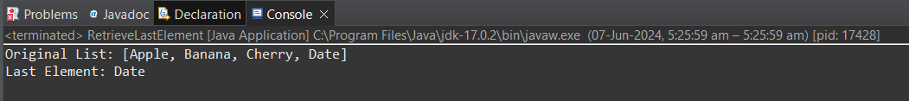

1. Write a Java program to create a LinkedList of integers and print all the elements.

Program :-

package Day07;

import java.util.LinkedList;

public class IntegerLinkedList {

public static void main(String[] args) {

// Create a LinkedList of integers

LinkedList<Integer> list = new LinkedList<>();

list.add(1);

list.add(2);

list.add(3);

list.add(4);

list.add(5);

// Print all the elements

System.***out***.println("LinkedList: " + list);

}

}

Output :-

